LAB 9 – Working With Local JSON Storage (Flutter + File Persistence)
1. Objective
In this lab, students will build three small Flutter tasks that teach how to store, read, and update data locally using JSON files.
This lab reinforces key concepts from Module 9 – JSON & Local Storage, including:
- Reading JSON from assets
- Writing JSON files to app storage
- Maintaining local persistence between app restarts
- Implementing simple CRUD operations on JSON data
- Designing UI that reflects local data changes
At the end, students will have a fully functional set of JSON-powered screens that run correctly in:
- DartPad (where applicable)
- Android Studio
- VS Code
2. Requirements
This lab is divided into three sub-tasks, each focusing on one major skill.
Lab 9.1 – Read JSON From Assets (Local Embedded File)
Lab 9.2 – Save & Load JSON From Device Storage
Lab 9.3 – JSON CRUD Mini Database (Search + Edit + Delete)
Students may complete them in separate Flutter projects OR in one combined project (recommended).
2.1 Functional Requirements
Lab 9.1 – Read JSON From Assets
The app must:
- Include a JSON file in the project /assets/
- Load JSON using rootBundle.loadString()
- Parse JSON into a Dart List
- Display data using ListView
- Show at least 2 fields per item
Lab 9.2 – Save & Load JSON Using Local Storage
The app must:
- Read JSON file from application documents directory
- Save updates back to the JSON file
- Persist data across app restarts
- Provide minimal UI:
  - Add item
  - Show list
  - Save button (or auto-save)
Lab 9.3 – Local JSON CRUD + Search
The app must include:
- A JSON file used as a local mini-database
- Ability to:
  - Add item
  - Edit item
  - Delete item
  - Search/filter items
- Automatically save JSON after every change
- Clean and functional list UI
2.2 Technical Requirements
Your projects must:
- Use Flutter + Dart only
- Use dart:convert for JSON encoding/decoding
- Use path_provider for accessing local storage (Lab 9.2 & 9.3)
- Use setState or State Management from module 7 (optional)
- Run without errors on:
  - DartPad (Lab 9.1 and parts of Lab 9.3)
  - Android Studio
  - VS Code
Required Widgets & Methods:
- ListView / ListView.builder
- FloatingActionButton
- TextField
- jsonDecode / jsonEncode
- File read/write (Lab 9.2 & 9.3)
- StatefulWidget
2.3 Optional Enhancements (Bonus)
Students may optionally:
- Add toast/snackbar messages after saving
- Add pull-to-refresh
- Add multiple JSON files
- Add confirm dialog before delete
- Auto-generate incremental IDs
- Create custom UI components
These are optional but improve your score.
3. Guided Steps
Lab 9.1 – Read JSON From Assets
Step 1 – Project Setup
Create new project and add JSON file inside assets/data/.
Step 2 – Register Assets in pubspec.yaml
Enable JSON file under flutter → assets.
Step 3 – Load JSON File
Use async loading (rootBundle.loadString) to read file content.
Step 4 – Decode JSON
Convert loaded string into a Dart List using JSON decode.
Step 5 – Display Data
Use ListView to show item fields.
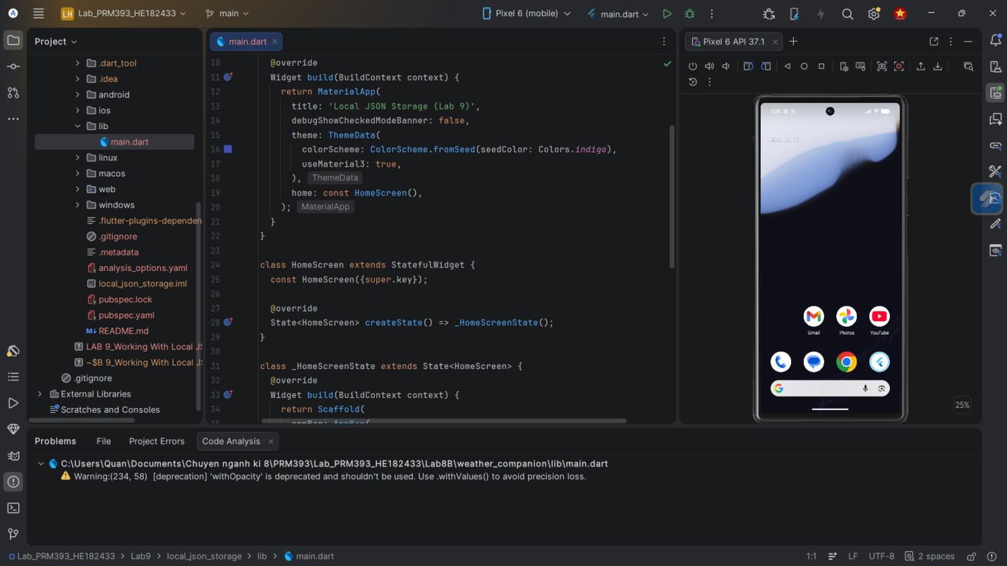
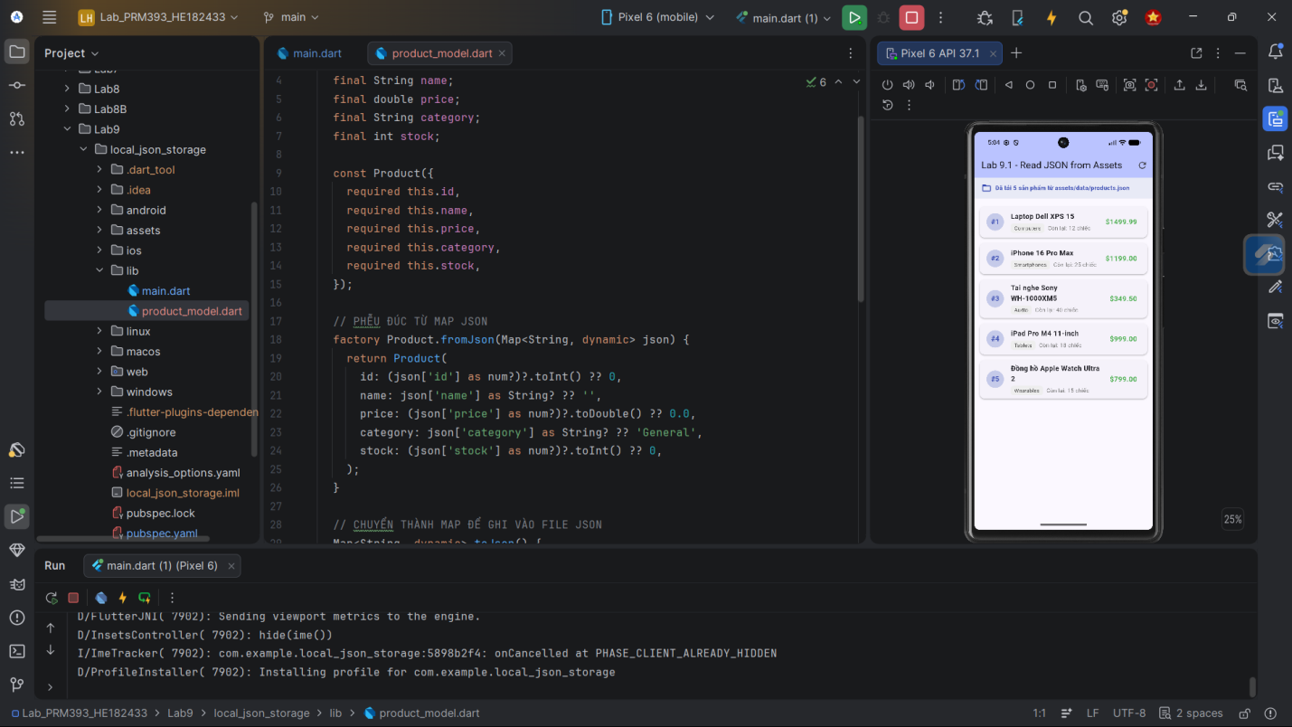
Lab 9.2 – Save & Load JSON From Device Storage
Step 1 – Add path_provider
Add required dependency to pubspec.yaml.
Step 2 – Create a Storage Service
Implement helper methods to:
- Locate app document directory
- Read existing JSON file
- Create a new file if not found
- Write updated JSON back to storage
Step 3 – Load Data at Startup
Read file during initState and load items into a list.
Step 4 – UI for Adding Items
TextField + Add button → append items to list.
Step 5 – Save Button
Write list to JSON file and show confirmation message.
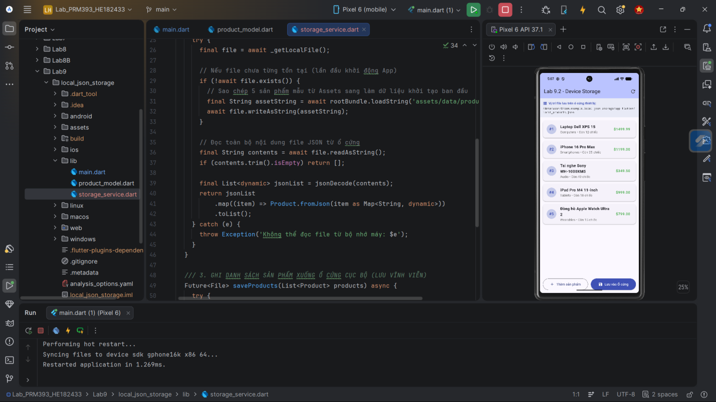
Lab 9.3 – JSON CRUD Mini Database
Step 1 – Local Data Structure
Prepare an in-memory list (loaded from JSON file).
Step 2 – Search Bar
Filter list by name or keyword.
Step 3 – Add / Edit / Delete
- Add: Create new item with unique ID
- Edit: Update fields of selected item
- Delete: Remove item after confirmation
Step 4 – Auto-Save
Re-save JSON file after each CRUD action.
Step 5 – Improved UI
Use ListTile or custom widgets to display item details.
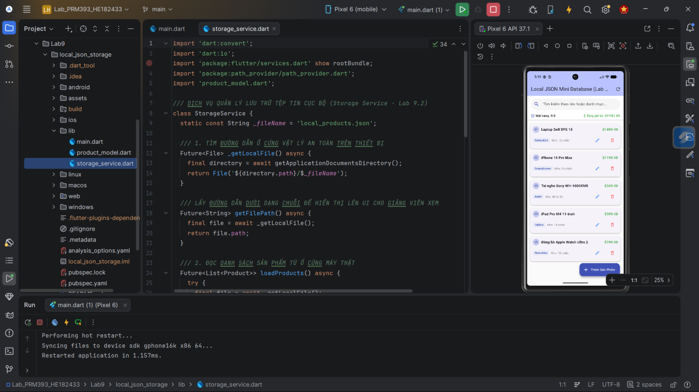
4. Expected Result
Your final Lab 9 output should:
- Correctly load JSON from assets (Lab 9.1)
- Correctly save JSON to device storage and reload after restart (Lab 9.2)
- Provide full CRUD interaction with JSON "database" (Lab 9.3)
- Feature responsive UI that updates on changes
- Run on:
  - Android Studio
  - VS Code
  - DartPad (Lab 9.1 & partial Lab 9.3)
5. Submission
Students must submit:
Required Deliverables
- A ZIP file of project(s)
- Or DartPad links for applicable tasks
- JSON files used in each lab
- Screenshots:
  - JSON loaded into list (Lab 9.1)
  - Saving & reloading data (Lab 9.2)
  - CRUD + Search UI (Lab 9.3)
Evaluation Criteria
Category | Weight | Description
JSON Reading | 25% | Correctly loads & parses assets JSON
JSON Writing | 25% | Proper save/load functionality
Local Persistence | 20% | Data persists after restart
CRUD Functionality | 20% | Add, edit, delete, search
UI/UX Quality | 10% | Clear layout, smooth interaction

